Q1. A statement is followed by two assumptions numbered (1) and (II). Consider the statement and assumptions. Decide which of the given assumptions is/are implicit in the statement?
Statement: Helping the poor is the real service to the humanity.
Assumptions: (I) Poor people are in need of help from others.
(II) If we do not help poor, we will not be called human being
(a) Only assumption (II) is implicit.
(b) Both assumptions (I) and (II) are implicit.
(c) Neither assumption (I) nor assumption (II) is implicit.
(d) Only assumption (I) is implicit.
Ans: (d)

Q2. If
(i) 'X@ Y' means 'X is the father of Y'.
(ii) 'X # Y' means 'X is the sister of Y'.
(iii) 'X $ Y' means 'X is the mother of Y'.
(iv) 'X% Y' means 'X is the brother of Y'.
Then, in the expression I$ J @ K% L# M, how is I related to M?
(a) Granddaughter
(b) Mother
(c) Father
(d) Grandmother
Ans: (d)

Q3. Six friends A, B, C, D, E and F went to a restaurant where every customer is offered a complementary dish with every ordered dish. D got Halwa as a complementary while three others ordered it. E and F have Pulihora as one of their dishes. F ordered Manchurian, which is complementary for both C and E. A's ordered and complementary dishes are Halwa and Pizza respectively, they are just reversed of those D's. Chicken as complementary given to only one of them. Which of the following group has ordered Halwa?
(a) A, C, E
(b) B, E, F
(c) C, D, E
(d) A, B, C
Ans: (d)

Q4. One term in the following number series is wrong. Find the wrong term.
24, 6, 18, 9, 36, 14, 24, 6
(a) 14
(b) 9
(c) 6
(d) 18
Ans: (a)

Q5. Study the given diagram carefully and answer the question. The numbers in different sections indicate the number of persons speaking that language.
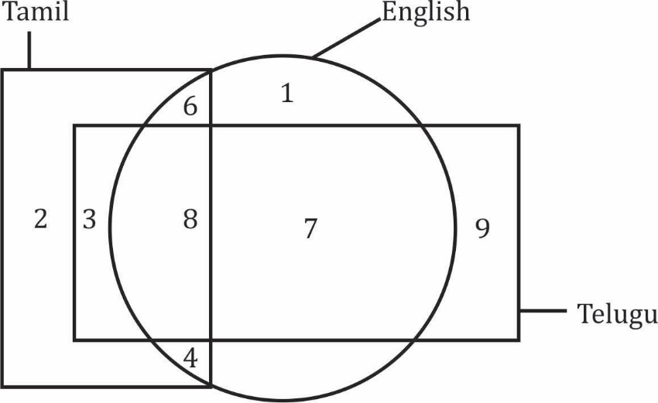
How many persons speak only one language?
(a) 11
(b) 12
(c) 13
(d) 10
Ans: (b)

Q6. If @ is the father of S, # is the mother of $β$. The sister of $ and Ω is β. Which of the following statements is definitely NOT true?
(a) β is the sister of $.
(b) B is the son of @.
(c) @ is the father of Ω.
(d) @ is the mother of Ω.
Ans: (d)

Q7. Select the letter-number cluster that will replace the question mark (?) in the following series.
X6L, T5J, P4H, L3F, ?
(a) H2D
(b) I2B
(c) K2C
(d) J2E
Ans: (a)

Q8. Study the following letter-number-symbol sequence and answer the question:
F@ 3 9 H C A D I % 4 E * $ M K 2 U R P 5 W 8 8 1 T J V 7
Three of the following four are alike in a certain way based on their positions in the above sequence and so form a group. Which is the one that is different from others?
(a) 2P$
(b) M*2
(c) KR
(d) A%9
Ans: (b)

Q9. Given below is a question followed by two statements numbered (1) and (II), each containing some information. Decide which of the statement(s) is/are sufficient to answer the question?
On which day of the week was Naresh born?
Statements:
(1) Naresh's birthday was one day after his sister's birthday.
(II) Naresh was born on the third day of the week.
(a) Statement (II) alone is sufficient to answer the question while statement (I) alone is not sufficient.
(b) Both statements (I) and (II) together are necessary to answer the question.
(c) Either statement (I) alone or statement (II) alone is sufficient to answer the question.
(d) Statement (I) alone is sufficient to answer the question while statement (II) alone is not sufficient.
Ans: (a)

Q10. Amit and Bhuvan start from the same point. Amit drives 50 km East. Bhuvan drives 15 km North then turns East and drives 20 km, then turns to his right and drives 15 km. Where and in which direction is Bhuvan now with respect to Amit?
(a) 70 km, East
(b) 30 km, West
(c) 70 km, West
(d) 30 km, East
Ans: (b)

Q11. In the following series, some of the letters are missing which are given in that order as one of the alternatives. Choose the correct option.
dcba__dc_b_dcc_add_cba
(a) cdbba
(b) acbdb
(c) ababd
(d) ddbca
Ans: (c)

Q12. The Venn diagram below best represents the relationship among which of the classes given in the options?
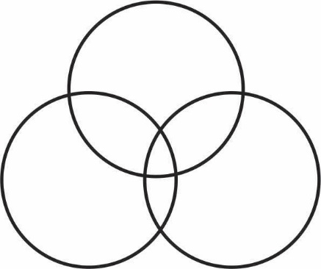
(a) Sparrows, Birds, Mice
(b) Students, Cricket Players, Tennis Fans
(c) Women, Mothers, Widows
(d) Beverages, Tea, Coffee
Ans: (b)

Q13. P is elder to Q while R and S are elder to T, who lies between P and R. If R is elder to Q, which one of the following statements is necessarily true?
(a) R is elder to S
(b) Q is elder to T
(c) S is elder to R
(d) P is elder to R
Ans: (c)

Q14. Point T is 11 m North of point U. Point V is 11 m East of point U. Point W is 6 m North of point V. Point X is 7 m West of point W. Point Y is 8 m North of point X. Point Z is 4 m West of point Y. How far and in which direction is point Z with respect to point T?
(a) 15 m, West
(b) 25 m, North
(c) 34 m, West
(d) 47 m, North
Ans: (a)

Q15. In a sports team of six members, P1 and P2 are from city and rest are from village. P4 and P6 are tall while others are short. P1, P3 and P4 are wearing shoes while others are not. Which short team member of city is not wearing shoes?
(a) P2
(b) P3
(c) P4
(d) P1
Ans: (a)

Q16. P and Q play football and cricket, Q and R play cricket and hockey, P and S play basketball and football, R and S play hockey and basketball. Who plays football, basketball and hockey?
(a) R
(b) Q
(c) P
(d) S
Ans: (c)

Q17. Three statements are given followed by two conclusions (1) and (II). Assuming the statements to be true even if they appear to be at variance with commonly known facts, decide which of the given conclusions is/are logically follow/follows from the statements?
Statements: Some envelopes are packets. Some packets are boxes. All boxes are parcels.
Conclusions: (I) Some parcels are packets.
(II) Some parcels are boxes.
(a) Only conclusion (II) follows.
(b) Both conclusions (I) and (II) follow.
(c) Neither conclusion (I) nor conclusion (II) follows.
(d) Only conclusion (I) follows.
Ans: (b)

Q18. In the following question, a relationship between different elements is shown in the statement followed by three conclusions numbered (I), (II) and (III). Assuming statement to be true, decide which of the conclusions is/are definitely true?
Statement: W≤V, V > X, Y≥V.
Conclusions:
(I) X<Y
(II) Y≥W
(III) X=W
(a) Only conclusions (II) and (III) are true.
(b) Only conclusions (I) and (II) are true.
(c) All conclusions (I), (II) and (III) are true.
(d) Only conclusions (I) and (III) are true.
Ans: (b)

Q19. Two statements are given below and these are labelled as Assertion (A) and Reason (R).
Assertion (A): Vitamin C is destroyed by heating.
Reason (R): Vitamin C is water-soluble and heat-sensitive.
Select the correct answer from the following options:
(a) Both (A) and (R) are true, but (R) is not the correct explanation of (A).
(b) (A) is true but (R) is false.
(c) (A) is false but (R) is true.
(d) Both (A) and (R) are true, and (R) is the correct explanation of (A).
Ans: (a)

Q20. H is heavier than J whereas M is heavier than P. L is as heavy as J. A is heavier than H. Which one of the following statements is definitely true?
(a) L is lighter than H.
(b) M is heavier than A.
(c) P is heavier than L.
(d) J is lighter than P.
Ans: (a)

PART - II: NUMERICAL ABILITY
Direction: Answer the following questions (Q. No. 21 to 40) by selecting the correct/most appropriates options.

Q21. The sum of the prime factors of 1729 is:
(a) 39
(b) 41
(c) 43
(d) 37
Ans: (c)

Q22. The next two terms in the series 4, 6, 9, 13, 18, ..... are:
(a) 21, 27
(b) 23, 28
(c) 24, 31
(d) 20, 25
Ans: (c)

Q23. On dividing a number by 96, the remainder obtained is 59. What would be the remainder, if the same number is divided by 24?
(a) 17
(b) 15
(c) 11
(d) 21
Ans: (c)

Q24. The sum of the principal and simple interest on it for 5 years at a certain rate of interest per annum is Rs. 28,000. If interest is 2/5 of the principal, then the rate of interest per annum is:
(a) 8%
(b) 6%
(c) 4%
(d) 10%
Ans: (a)

Q25. An operation is such that a + b = b - 2a + $\frac{ab}{5}$. Then, the value of 3+5 is:
(a) 36
(b) 35
(c) 34
(d) 37
Ans: (c)

Q26. Among the fractions, $\frac{3}{4}$, $\frac{5}{8}$ and $\frac{8}{11}$, the greatest fraction is:
(a) $\frac{3}{4}$
(b) $\frac{5}{8}$
(c) $\frac{8}{11}$
(d) $\frac{2}{5}$
Ans: (c)

Q27. The cost price of a table is Rs. 6,600. It is sold at a gain of ₹ 600 after giving a discount of 10% on the marked price. Its marked price is:
(a) Rs.8,400
(b) Rs.8,000
(c) Rs.7,200
(d) Rs.9,000
Ans: (b)

Q28. Following table depicts the favourite games of the people of a colony: (one person one game)
Game | Liked by Number of persons
Basketball | 470
Football | 510
Cricket | 1240
Hockey | 1430
Badmintion | 350
The number of persons liking the most favourite game is what percent of the total number of persons liking the games?
(a) 33%
(b) 35%
(c) 35 $\frac{3}{4}$%
(d) 31%
Ans: (b)

Q29. If simple interest on a certain sum at 6% per annum for 4 years is Rs. 1,600, then what will be compound interest on the same sum at the same rate of interest for two years?
(a) Rs. 824
(b) Rs. 832
(c) Rs. 848
(d) Rs. 816
Ans: (a)

Q30. A 320 metre long train crosses a platform with a speed of 120 km/hour in 24 seconds. If a person crosses the same platform in 12 minutes, then the speed of the person (in km/hour) is:
(a) 2.4
(b) 3.2
(c) 4.8
(d) 1.6
Ans: (a)

Q31. The value of expression 16 × 16 – 6 – 2 × 3 – 8 ÷ 4 is:
(a) 247
(b) 245
(c) 243
(d) 253
Ans: (b)

Q32. How many three digit numbers are divisible by both 4 and 6?
(a) 75
(b) 76
(c) 77
(d) 74
Ans: (a)

Q33. A sum of Rs. 73,689 was divided between two persons A and B in the ratio 4:7. The difference between thrice part of A and twice part of B is:
(a) Rs. 20,098
(b) Rs. 26,796
(c) Rs. 36,196
(d) Rs. 13,398
Ans: (d)

Q34. The value of $\frac{\left(15.6 x 6.5 x 6.25\right)}{2.5 x 1.25}$ is:
(a) 104
(b) 52
(c) 75
(d) 150
Ans: (d)

Q35. The average of 20 numbers was calculated as 56. It was found that a number 61 was misread as 64 in the calculation. The correct average of the numbers is:
(a) 55.65
(b) 54.85
(c) 54.65
(d) 55.85
Ans: (d)

Q36. HCF and LCM of two numbers are 28 and 336 respectively. If one of the numbers is 112, then difference of the two numbers is:
(a) 56
(b) 28
(c) 14
(d) 72
Ans: (b)

Q37. The perimeter of a rectangle is 28 cm and its breadth is 2 cm less than its length. Area of the rectangle is:
(a) 48 sq. cm
(b) 72 sq. cm
(c) 36 sq. cm
(d) 96 sq. cm
Ans: (a)

Q38. Out of two given numbers, 5% of one number is equal to 2% of the other number. If the difference of the two numbers is 2340, then what is the sum of these two numbers?
(a) 4500
(b) 5460
(c) 6402
(d) 3950
Ans: (b)

Q39. A certain work can be completed by 8 persons in 25 days. If the work is to be completed in 5 days, then how many more persons are needed for the same?
(a) 32
(b) 36
(c) 40
(d) 30
Ans: (a)

Q40. A shopkeeper purchased 245 articles at Rs. 30 per article and spent Rs.2,450 on their packages. If he sold these articles at Rs. 50 per article, then his gain percent is:
(a) 25%
(b) 21.5%
(c) 20%
(d) 27.5%
Ans: (a)

PART - III: BASIC COMPUTER LITERACY

Direction: Answer the following questions (Q. No 41 to 60) y selecting the correct/most apports options.

Q41. Which of the following is an example of an open-source spreadsheet software?
(a) Impress
(b) Calc
(c) Writer
(d) Microsoft Excel
Ans: (b)

Q42. An online system that helps people to find information on the internet by scanning web pages and other online resources and presenting a list of relevant results based on user input is called:
(a) Search Engine
(b) Web Server
(c) Social Media Platform
(d) Web Browser
Ans: (a)

Q43. 8 bits together make a_____________.
(a) Octabit
(b) Nibble
(c) Kilobyte
(d) Byte
Ans: (d)

Q44. With respect to Computer Networks, in the acronym WWW, the W in the second position refers to:
(a) Web
(b) Website
(c) Wide
(d) World
Ans: (d)

Q45. Find an input device out of the following.
(a) Speaker
(b) Joystick
(c) Barcode Printer
(d) Plotter
Ans: (b)

Q46. ________ a collection of data and information that forms a single entry on the World Wide Web, displayed in a browser, which can contain text, images, videos and hyperlinks to other such documents.
(a) Cookies
(b) Web Browser
(c) Web Page
(d) Computer Program
Ans: (c)

Q47. Which one is the default file extension of Calc spreadsheets?
(a) .sheets
(b) .calcx
(c) .ods
(d) .xlsx
Ans: (c)

Q48. Which among the following is utility software?
(a) WinRAR
(b) Device Driver
(c) VLC Player
(d) MS PowerPoint
Ans: (a)

Q49. It is an easy-to-use online tool available to create and collect organised data online just by providing its URL to the data contributors.
(a) Calc
(b) Acrobat Reader
(c) Google Forms
(d) MS Access
Ans: (c)

Q50. Which one of the following cannot be considered as a Cyber Crime?
(a) Writing abusive language in comment of a social media post
(b) Gaining access to password of someone's email and sending unnecessary information and large size files to everyone in the contact list
(c) Posting pornographic content on an online public platform
(d) Providing socially beneficial information on a social media website
Ans: (d)

